Analysis Normal Form (ANF) Principles and Terminology Modeling Guidelines
Knowledge Based Systems (KBS)
Office of Health Informatics (OHI)
Veterans Health Administration (VHA)
Department of Veterans Affairs (VA)
3/31/2018

Contents
1 Analysis Normal Form (ANF) Clinical Statement Model 1
1.1 Introduction 1
1.2 Modeling Principles 1
1.3 Clinical Statements – What are they, and how are they used? 2
1.4 Types of Clinical Statements 3
1.4.1 Performance Clinical Statements 4
1.4.2 Request Clinical Statements 5
1.5 Clinical Statement Building Blocks 5
1.5.1 UUID 5
1.5.2 Logical Expression 5
1.5.3 Stamp Coordinate 5
1.5.4 Measure 6
1.6 Clinical Statement Components 7
1.6.1 Statement Identifier 8
1.6.2 Mode 9
1.6.3 Stamp Coordinate 9
1.6.4 Narrative 9
1.6.5 Statement time 9
1.6.6 Subject of Record Identifier 9
1.6.7 Statement Authors 9
1.6.8 Subject of Information 9
1.6.9 Statement Type 9
1.6.10 Topic 10
1.6.11 Circumstance 10
1.6.12 Statement Associations 13
1.7 Examples of Modeling Performance Clinical Statements 14
1.8 Examples of Modeling Request Clinical Statements 15
2 VA KNART Terminology Modeling Guidelines 16
2.1 Introduction 16
2.2 Background 16
2.3 KNART Types and Structure 16
2.3.1 Documentation Templates 17
2.3.2 Order Sets 17
2.3.3 Consultation Request 17
2.3.4 ECA Rule 17
2.4 Terminology Service Request (TSR) 18
2.5 VA KNART Information Modeling Overview 19
2.6 Terminology Modeling Guidelines 19
2.6.1 Instance Request (Request and Performance) 19
2.6.2 statementID (Request and Performance) 19
2.6.3 statementType (Request and Performance) 19
2.6.4 METADATA: model fit (Request and Performance) 20
2.6.5 METADATA: model fit comments (Request and Performance) 20
2.6.6 VA CDS Team IR Review Rating (Request and Performance) 20
2.6.7 VA CDS Team Reviewer Initials (Request and Performance) 20
2.6.8 subjectOfInformation (Request and Performance) 20
2.6.9 topic (Request and Performance) 21
2.6.10 Unstructured (Request and Performance) 23
2.6.11 statementAssociation.semantic (Request and Performance) 24
2.6.12 statementAssociation.statementId (Request and Performance) 24
2.6.13 Timing (Request and Performance) 24
2.6.14 Purpose (Request and Performance) 26
2.6.15 requestedResult (Request and Performance) 27
2.6.16 conditionalTrigger (Request) 28
2.6.17 conditionalTrigger.statementId (Request) 28
2.6.18 Priority (Request) 29
2.6.19 repetition.period (Request) 29
2.6.20 repetition.eventFrequency (Request) 30
2.6.21 repetition.eventSeparation (Request) 31
2.6.22 repetition.eventDuration (Request) 32
Appendix A: Modeling Principles Definitions 33
Appendix B: Use Case for Modeling of Clinical Statements Using Analysis Normal Form 36
Depression: Follow-up outpatient visit (slightly adapted) 36
Breakdown of encounter into clinical statements 37

List of Figures

Figure 1. Measure 6
Figure 2. Clinical Statement 7
Figure 3. Participant 9
Figure 4. Circumstance, including request, performance, and unstructured subtypes 10
Figure 5. Request circumstance 11
Figure 6. Repetition 12
Figure 7. Performance 12
Figure 8. Statement Association 13
Figure 9: Order Example (Cardiology Order Set) 18
Figure 10: Order Set Instance Request in TSR Template 18
Figure 11: Rating Key 20
Figure 12: RxNorm SCD Code 21
Figure 13: RxNorm SCDG Code 22

List of Tables

Table 1: Example Clinical Statement Model 8
Table 2: Timing - unspecific 25
Table 3: Timing - specific range 26
Table 4: Timing - specific date 26
Table 5: requestedResult - Example 1 28
Table 6: requestedResult - Example 2 28
Table 7: repetition.period Example 30
Table 8: repetition.eventFrequency - Example 1 31
Table 9: repetition.eventFrequency - Example 2 31

Analysis Normal Form (ANF) Clinical Statement Model

Introduction

The purpose of this document section is:

- To define a clinical statement.
- To define the types of clinical statements and their attributes.
- To provide a set of guidelines to model clinical statements.
- To provide a validation framework for inter-modeler reliability when applied in the field.
- To provide information on how clinical statements will be modeled for the KBS Clinical Decision Support (CDS) Knowledge Artifact (KNART) project. Once the models are approved, model slots bound to terminologies will be identified for subsequent terminology binding definitions proposed by the VA Terminology Team. Modeling of clinical statements outside of the CDS KNART project is currently beyond the scope of this effort.
  - KNART example: Consult request to Cardiology to evaluate chest pain. Certain information must be collected and stored as structured data, such as the reason for the consult.

These modeling guidelines were derived from several documented use cases. The main goal of this effort is to provide a reproducible and a principled approach to the formal capture of clinical knowledge within Information Models and their references to underlying Terminology Models. Currently, the proposal and examples are independent of any specific terminology.

These guidelines will be distributed to a variety of participants to contribute to a modeling exercise. After having read the guidelines, participants will be asked to access a survey where they will view a number of clinical statements and indicate how they would model them. When attempting the modeling exercise, it will be important to model per the guidelines specified in this document regardless of how existing terminologies, such as SNOMED CT (SCT), may model these concepts. In the future, an exercise to reconcile approaches may be conducted but is out-of-scope at this time.

Modeling Principles

The modeling guidelines were developed in accordance with the principles shown below. These principles are defined in Appendix 4.1.

- Separation of Concerns
- Immutability
- Composition Over Inheritance
- ANF Clinical Statements Represent the Minimum Disjoint Set
- ANF Classes Cleanly Separate Concerns
- Clinical Statement Model Stability
- Overall Model Simplicity
- Cohesion
- Reusability
- Assumption-free
- Design by Composition over class specialization.
- No False Dichotomies
- Model Should Avoid Semantic Overloading (semantic precision)
- Convention Over Configuration
- Model Consistency
- Model Symmetry
- Iterative development and validation using use cases

Clinical Statements – What are they, and how are they used?

A clinical statement represents an entry in the patient record that documents in a structured/computable manner clinical information about a subject of information, such as a patient or a relative of the patient, and that is asserted by a particular source, recorded, and potentially verified.

Clinicians author clinical statements and enter them into their organization’s electronic health record (EHR). Clinicians typically enter the information via a manner that we call here the clinical input form (CIF). However, the CIF is not a literal form that clinicians select and enter data in. Rather, it refers to the manner in which information is presented to the clinicians and how they enter the data, such as by constraining the information to allow only certain values to be entered, such as through a drop-down list or radio button, or breaking up large chunks of related information into smaller parts. For example, when a clinician orders a medication, rather than selecting this information all at once with a single item, they will choose the various parts of the medication order, such as:

- Kind of drug and strength (e.g., Acetaminophen 150 mg)
- Amount and how often the patient should take the medication (e.g., 1 tablet twice daily)
- Duration (2 days)
- Any constraints (e.g., do not exceed a total daily dosage of 600 mg)

Ideally, the way the information is presented to clinicians is in a manner that is most efficient for the clinicians to use. However, what is an efficient way for clinicians to select and enter data may not be the most efficient way for data analysts to use when they are querying data once it has been normalized and stored in a database, such as when creating a new CDS rule or compiling prevalence statistics. For this, the data is normalized using the analysis normal form (ANF) and stored in a database. Again, the ANF is not necessarily a physical structure, but is how a data analyst might see the data when they are looking at it in a database, and not as clinicians would see it in the user interface (i.e., CIF).

- Clinician collects data Clinical Input Form
- Data is normalized Transformation process from CIF to ANF Representable/storable in multiple types of databases, which could include VistA but a separate process would need to be performed to make that happen.
- Data analyst who is using or querying the data (e.g., creating a CDS rule or working on prevalence statistics) ANF (it is how the data is represented or stored in the database; must know enough about the data to know what is stored in the topic vs. what is stored as a result or detail)

The goal of ANF is to enable analysts to understand the data and how it is stored in lieu of having to teach them about the thousands of ways data can be entered (i.e., CIF) and ensure the data that has to be expressed can be expressed in an operable and scalable way. The more that data is normalized, the simpler it will become to analyze, and the likelihood of analysis errors will be reduced. Without the ANF, the probability of patient safety risks is increased. Examples of problems that can occur are:

- An inability to determine that two clinical statements are equivalent
  - Taking two 250 mg acetaminophen tablets is the same as taking one 500 mg tablet but the analyst only queries for one of the statements, not both.
  - Presence of dot blot hemorrhage and 2 dot blot hemorrhages observed are equal in regard to presence and absence but the analyst queries only for presence vs. a quantitative finding of dot blot hemorrhages.
- An inability to express something that is clinically significant
  - We may not be able to express chest pain on inspiration, which can be a sign of pleurisy. The ability to differentiate cardiac chest pain from other types of chest pain is clinically important. An example of something that needs to be represented is chest pain that worsens when you breathe, cough, or sneeze.
- An error is made in recording or in querying a repository for clinical statements
  - On October 1, 2016, a provider enters a medication order for acetaminophen 250 mg for a patient to take 1 tablet twice daily for 2 days starting October 1, 2016
    - CIF: Provider enters the medication order
    - ANF: Analyst creates a CDS rule to identify all patients ordered acetaminophen during the period September 1 – December 31, 2016. However, while the analyst creates a query to search for a clinical statement (i.e., Request) where acetaminophen was the direct substance and was ordered during the period September 1 – December 31, 2016, the analyst did not include a Request topic of “Administration of drug or medication PO BID for pain.” Thus, the medication order would not be included in the query results.

Types of Clinical Statements

The types of clinical statements are listed and described below. The rationale for selecting these types is: Clinicians basically do two categories of things with a patient that need to be documented as clinical statements:

- Performance of action: Actions may include passive observation of a phenomenon related to patients and their health status or family history, and may also include active interventions, such as providing education or administering medications or documenting that a patient is participating in exercise to improve their overall health status.
- Request for action: Requests for future actions may include defining goals, consultation with other providers, or active interventions.

NOTE: Given that this work is not yet finalized, it is possible that additional clinical statement types may need to be added in the event during creation of the KNARTs there are clinical terminology artifacts identified that do not fit into any of the types listed above.

Any statement that states or implies an “if/then” clause should be expressed and captured as an Event/Condition/Action (ECA) rule
Example:
  - “Free-text reminder: Consider [ordering X procedure] for patients with suspected pericarditis, myocarditis, hypertrophic cardiomyopathy, or pulmonary hypertension.”
  - Implied “if/then” clause: IF pericarditis, myocarditis, hypertrophic cardiomyopathy, or pulmonary hypertension is suspected – THEN consider ordering X procedure.
  - Rather than capturing the above statement as a free text reminder, building an appropriate ECA rule should be considered.

Performance Clinical Statements

A performance statement describes an action that has previously been performed, and – if applicable - the results of that action. As shown in the examples below, this can range from documenting that a subject of record:
- Was observed to have the presence or absence of a clinical phenomenon
- Underwent a specific test/screening or procedure, and its resultant value, if any
- Was administered a medication or other substance
- Was provided educational materials
- Has any other state or specific characteristic that is clinically relevant

If the performance statement:
- Regards a measurement that was taken, all information about that measurement will be included as part of the clinical statement, such as its value and unit of measure and any details about how the measurement was taken.
- Results in an order(s) placed during the same encounter that was made to learn more about the phenomenon or to monitor it, then a link will be made to the order(s).

Examples of performance clinical statements:
- Systolic blood pressure of 120 mmHg taken from right brachial artery while seated and no more than 30 minutes after the patient last urinated
- Diabetes mellitus is present
- Diabetes mellitus is not present
- Three dot blot hemorrhages
- Dot blot hemorrhage is present
- Patient taking one Acetaminophen 100 mg tablet by mouth daily as needed for pain
- Positive screen for fall risk
- Negative screen for PTSD and depression
- Family history of colon cancer
- Patient provided educational materials on pre-diabetes diagnosis
- Patient counseled on the health risks of continuing smoking

Request Clinical Statements
A Request clinical statement describes a request for an action made by a clinician. Most of the times, but not always, the object of the request (e.g., lab test, medication order) will be fulfilled by someone other than the clinician (e.g., lab technician, pharmacist) making the request. All information about the request will be documented in this clinical statement, including information about details relating to the request, such as patient must fast for 12 hours before having a lipids blood test.
Examples of Request clinical statements:
- Lipids panel for patient Jane Doe. Patient must fast for 12 hours prior to the blood test.
- Head CT with contrast for patient John Doe.
- Cardiology referral for patient Mary Smith.
- Penicillin medication for patient Michael Smith to be taken twice a day by mouth with food for 10 days.
- Advised to participate in group tobacco cessation counseling once a week.
- Advised to lose 15 pounds within 3 months.
- Advised to exercise at least 3 times a week for 30 minutes per day for 3 months.
- Advised to decrease the number of packs smoked per day from 3 to 2 within 6 months by using a nicotine patch.

Clinical Statement Building Blocks
The following components are used in multiple places within clinical statements.

UUID
The UUID is the means by which all clinical statement items that require unique identifiers are identified.

Logical Expression
Logical Expressions are used to encode elements of clinical statements, using pre-coordinated or post-coordinated expressions from standard terminologies such as SNOMED CT, RxNorm, LOINC (SOLOR Terminologies).

Stamp Coordinate
[SOLOR Module], [Release Path], [Date/Time in ISO 8601 Standard Format]

Measure
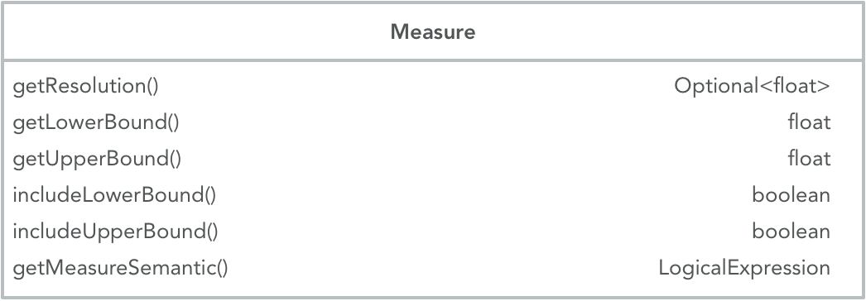
Figure 1. Measure
Measures capture measurable elements of clinical statements, e.g. the results of test procedures, time periods, frequencies of repetitions for procedures or medication administrations.

Lower Bound
Represents the lower bound of a measurable element. This can be the lower bound of a range: For the “Administration of 25 to 50 mg of medication X” the lower bound is 25. For a test result, which is not a range, lower and upper bound are the same. Example: systolic blood pressure 110 mmHg. The lower and upper bound are both 110 mmHg.

Upper Bound
Represents the upper bound of a measurable element. This can be the upper boundary of a range: For the “Administration of 200 to 250 mg Acetaminophen” the upper bound is 50 mg. In cases, where the measurable element does not represent a range, upper and lower bound have the same value.

Include Lower Bound
In the examples above, the lower bound has to be included. The lower range dose of 200 mg Acetaminophen dose can be administered.
The inclusion or exclusion of lower bound is needed to express measurable elements which include relative properties, such as “greater than”, “less than” and others. Example: “Persistent cough for more than 10 days”. If a lower bound of “10” is chosen, it would not be included, because the example states: more than 10 days. Choosing “11” would require to include the lower bound.

Include Upper Bound
Similar to lower bound. Where the measurable element has relative properties, the same rules apply. If the upper bound of a measure is not defined, e.g. “blood glucose measurement daily for at least 2 weeks”, the upper bound will be captured as “inf” (infinite). Infinite as an upper bound is never included.

Resolution
The Resolution within a measure defines the possible or allowed increments in which the measured “thing” can be counted. In the example of the systolic blood pressure of 110 mmHg, the resolution is “1”, because the blood pressure measurement result can be counted in 1 mmHg increments. The Resolution is not always defined or known. Example: a clinical statement like “History of breast cancer” implies an undefined amount of time in the past and it is not stated, if it is years, months, etc.

Measure semantic
Measure semantic represents distinct units of what is being measured in a logical expression. In the systolic blood pressure examples, the measure semantic is a SNOMED CT concept: 259018001 |Millimeter of mercury (qualifier value). For blood glucose measurement daily for 2 weeks, the measure semantic would be “258705008 |week (qualifier value)”. In cases where the measure pertains to something relative to the statement time, as in the example above of “History of breast cancer” the standardized time/date format ISO 8601 is used for the measure semantic: ISO 8601 prior to statement time.

Clinical Statement Components

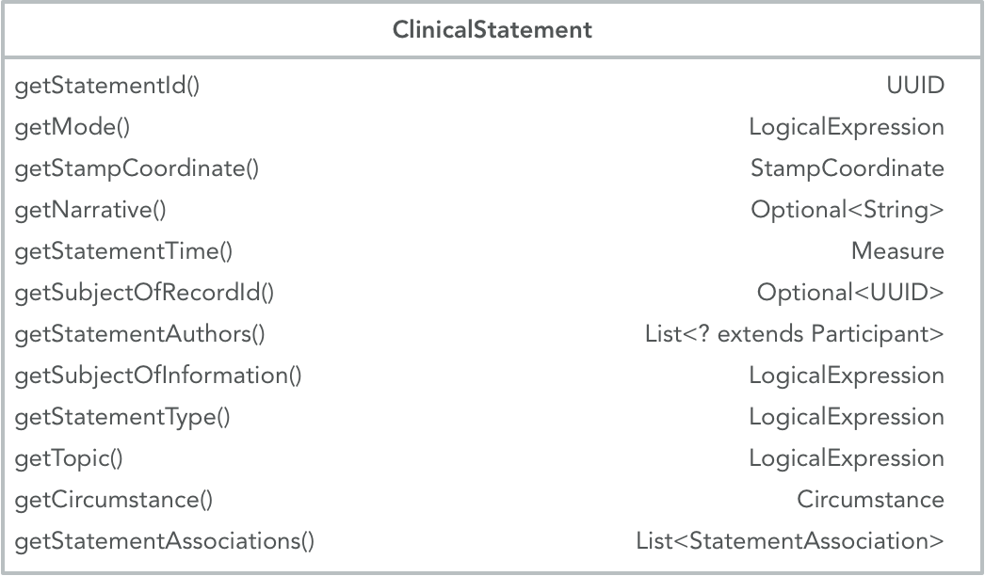
Figure 2. Clinical Statement

The clinical statement model is comprised of a number of defined components, which are either required or optional to capture the elements of a clinical statement.

Clinical Statement
Narrative: Ibuprofen 400 mg tablet oral every 6 hours as needed for back pain; may increase dose frequency to one tablet every 4 hours
Statement type: [Request]
Subject of info: [410604004 |Subject of record]
Mode: [Template]
Authors: [223366009|Healthcare professional]
Action topic: [71388002|Procedure]-
→(260686004|Method)→[129445006|Administration - action]
→(363701004|Direct substance)→[197805|Ibuprofen 400 MG Oral Tablet]
→(410675002|Route of administration)→[260548002|Oral]
Circumstance: | Request Circumstance
Timing: [2007-04-05T14:30Z, 2007-04-05T15:00Z]±P5M [ISO 8601]
Purposes: [161891005 |Backache (finding)]
Triggers: Ø associate statement backache present Participants: [410604004 |Subject of record]
Priority: [50811001 |Routine (qualifier value)]
 | Repetitions: | Repetition
 |  | Start: Duration: Frequency: Maximum: Duration:
 | Result: 4
Associations: Ø
Statement time: [2007-04-05T14:30Z, 2007-04-05T15:00Z]±P5M [ISO 8601]
Stamp coordinate: [SOLOR Module], [Release Path], 2007-04-05T14:30Z Statement id: a3b46565-f8cd-4354-b4b6-3dff42d33496
Subject of record Ø ID:

Table 1: Example Clinical Statement Model

Statement Identifier
The UUID is the means by which all clinical statements that require unique identifiers are identified.

Mode
?? Needs clarification

Stamp Coordinate
[SOLOR Module], [Release Path], [Date/Time in ISO 8601 Standard Format]

Narrative
The clinical statement as a whole, e.g. “Ibuprofen 400 mg tablet oral every 6 hours as needed for back pain; may increase dose frequency to one tablet every 4 hours”

Statement time
Time when the statement was documented in ISO 8601 Date/Time Standard Format

Subject of Record Identifier
UUID identifier for the subject of record.

Statement Authors

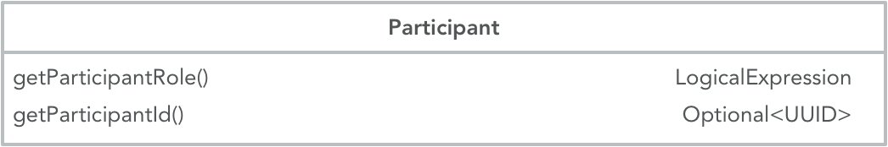
Figure 3. Participant
Optional list of participants, e.g. “Healthcare professional”, “Nurse”

Participant Role
Optional role for participants, e.g. “Requester”.

Participant Identifier
Optional. UUID Identifier for the participant.

Subject of Information
Subject of Information is used to express WHO the clinical statement is about, e.g. the patient or a family member.

Statement Type
Statement Type distinguishes between a performance (“performed”) and a request (“requested”). Performances may be observational performances, e.g. the observation of a clinical finding or disorder being present or absent. They can also be statements of a procedure or intervention, which has been performed on the subject of record in the past, e.g. “12-lead electrocardiogram”. Performances can – but do not have to – include quantitative or qualitative results, e.g. “3 dot blot hemorrhages” or “Hepatitis A antibody positive”.

Topic
The topic is the expression of WHAT is being requested or what was performed. For both clinical statement types (request or performance) a pre-coordinated or post-coordinated SOLOR “procedure” concept as a logical expression is required to sufficiently capture the action, which is either requested or performed.

Requests for actions are always procedures or interventions:
- Stress echocardiogram
- Administration of Aspirin 81 mg oral tablet
- Systolic blood pressure measurement

Performances of actions can be performed procedures like the examples above. They can also be observational procedures, describing the absence or presence of clinical findings or disorders. In these cases, the observation action of the clinical findings and disorders is performed:
- Congestive heart failure
- History of malignant neoplasm of bone
- Numbness of left arm
- History of cognitive behavioral therapy

The topic is the central component of clinical statements.

  - Proposed Principle 1: The topic defines the action being performed or requested.
  - Proposed Principle 2: The topic has to be able to exist on its own and still retain original intent and clarity of meaning.
  - Proposed Principle 3: The topic includes what is being measured or observed.
  - Proposed Principle 4: Each clinical statement may only have one topic.

Circumstance

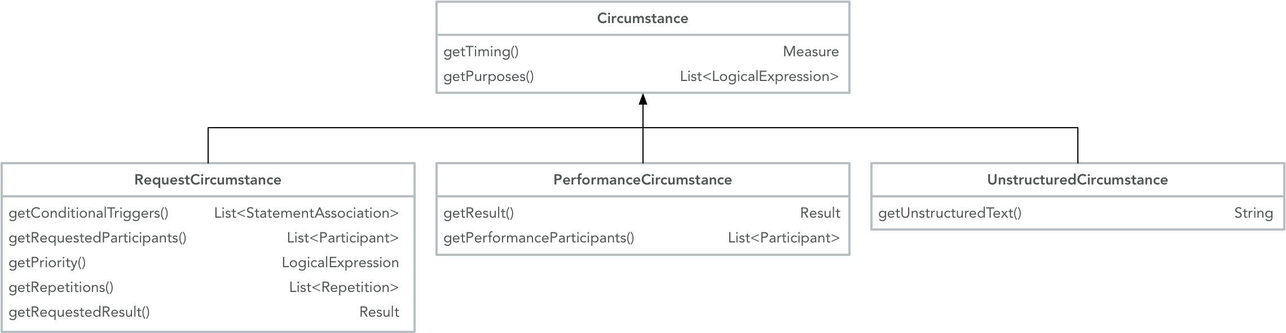
Figure 4. Circumstance, including request, performance, and unstructured subtypes
Circumstances can describe HOW, WHY and WHEN a requested or performed action will be or was carried out. Requests and performances have some shared circumstances:

- Timing: WHEN a requested action should be performed or WHEN an observed finding or disorder was present or absent.
  - Examples:
    - Cardiology Consult in 2 weeks
    - Breast cancer screening 3 months ago

- Purpose: WHY an action was requested or performed
  - Examples:
    - Echocardiogram to evaluate arrhythmia
    - Education about allergens for anaphylaxis management

Other circumstances are specific to requests or performances.

Request Circumstance

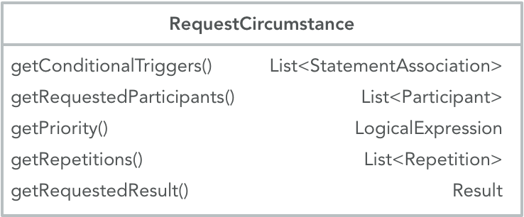
Figure 5. Request circumstance
Request circumstance further specify HOW a requested action is to be performed, e.g. how often or how long.

Conditional Triggers
??

Requested Participants
Requested participants can be either specific persons or roles who perform an action, assist in performing an action or are targets of an action.

Examples:
- Cardiology consultation with Chief Cardiologist
- Smoking cessation education with patient and patient’s spouse

Priority
Expresses the priority with which a requested action has to be carried out, e.g. “routine” or “stat”.

Repetition

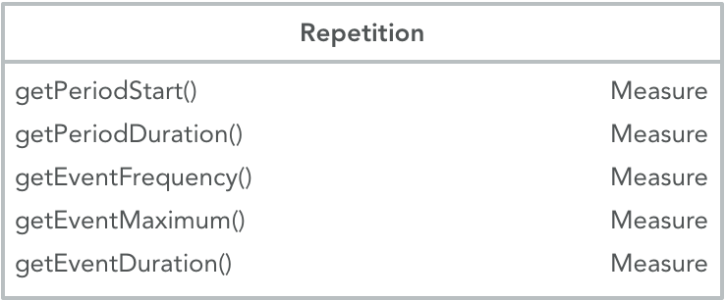
Figure 6. Repetition
If an action is requested for more than a single occurrence, the repetition allows to specify:
- When the repeated action should begin (PeriodStart), e.g. NOW
- How long the repetitions should persist (PeriodDuration), e.g. for 3 weeks
- How often the action should occur (EventFrequency), e.g. 3 times per week
- Maximal number of occurrences (EventMaximum), e.g. 10 times
- How long every occurrence should last (EventDuration), e.g. for 5 minutes

Requested result
A patient goal to be achieved or a request for action further specified or quantified.

Examples:

Narrative: Administration of Metoprolol tartrate 50 mg oral daily 2 times to lower systolic blood
pressure to <130 mmHg

Narrative: Diltiazem 30 mg, one tablet oral daily 4 times

Performance Circumstance

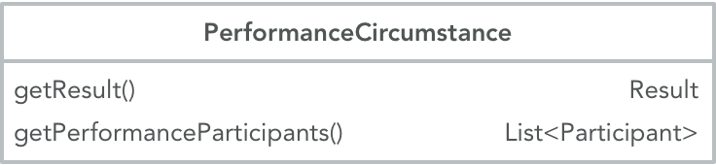
Figure 7. Performance

Result
Result of diagnostic or observational procedures

Examples:

Narrative: Systolic blood pressure 120 mmHg

Narrative: Body weight 165 pounds

Performance Participants
Participants in performing the action, e.g. technician, nurse

Unstructured Circumstance
Used to document additional parts of clinical statements, which are not necessary for accurate data coding or retrieval.

Unstructured Text
Text field to document unstructured circumstances.

Statement Associations
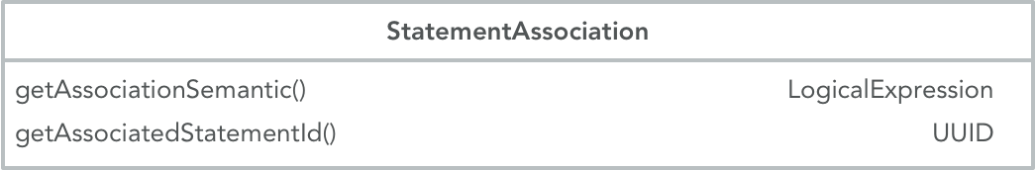
Figure 8. Statement Association
Statement associations are parts of the narrative, but are not considered parts of the topic. They can further specify, e.g. instructions that apply to the performance of an action.

Association Semantic
Logical expression to capture associated statements.

Associated Statement ID
UUID to identify associated statements.

Examples of Modeling Performance Clinical Statements
Action Clinical Statement Examples | Topic | Circumstance | Statement Association
- Systolic blood pressure of 120 mmHg taken from right brachial artery while seated and no more than 30 minutes from when the patient last urinated | Observation of systolic blood pressure on right brachial artery | Observation Result  Value: [120, 120]  Unit: mmHg  Resolution: 1 | Associated Statement  Seated  Rested for at least 10 minutes  Urinated within 30 minutes of BP being taken
- Patient has systolic blood pressure of 122 mmHg while patient is seated, right brachial artery | Observation of systolic blood pressure on right brachial artery | Observation Result  Value: [122, 122]  Unit: mmHg  Resolution: 1 | Associated Statement  Seated
- Patient has systolic blood pressure of 125 mmHg, while patient is seated, adult cuff, 30 minutes or less after emptying bladder, at doctor’s office | Observation of systolic blood pressure | Observation Result  Value: [125, 125]  Unit: mmHg  Resolution: 1 | Associated Statement  Adult automated cuff used  Seated  Urinated within 30 minutes of BP being taken  Taken at Doctor’s office
- Patient has thromboembolism history | Observation of thromboembolism | Observation Result  Value: [1, inf)  Timing  Value: [1, inf)  measureSemantic: ISO 8601 prior to statement time
- Diabetes Mellitus present | Observation of Diabetes Mellitus present | Observation Result  Value: [1, inf)
- Diabetes Mellitus not present | Observation of Diabetes Mellitus absent | Observation Result  Value: [0,0]
- Three dot blot hemorrhages | Observation of Dot blot hemorrhage | Observation Result  Value: [3,3]  Unit: count
- Dot blot hemorrhage present | Observation of Dot blot hemorrhage | Observation Result  Value: [1, inf)

Action Clinical Statement Examples | Topic | Circumstance | Statement Association
- Positive screen for fall risk | Observation of fall risk | Observation Result  Value: [1,1]  Unit: count
- Family history (mother) of colon cancer | Observation of colon cancer | Value: [1,inf)]  measureSemantic: ISO 8601 prior to statement time

Examples of Modeling Request Clinical Statements

Orders Clinical Statement Examples | Topic | Circumstance | Statement Association
- Administration of Acetaminophen 100 mg tablet by mouth daily as needed for pain | Administration of Acetaminophen 100 mg tablet oral | Requested Result  Value: [1,1]  Resolution: (1)  measureSemantic: Oral tablet  Frequency  Value: [1,inf)  Resolution: 1  measureSemantic: day  Purpose  Therapeutic; Pain
- Request for x-ray chest to evaluate chest pain (routine) | Performance of Chest x-ray | Priority: Routine  Purpose: Evaluation; chest pain
- Request for administration of nitroglycerin 0.4 mg tablet sub-lingual every 5 minutes as needed for chest pain; maximum 3 tablets (routine) | Administration of nitroglycerin 0.4 mg tablet sublingual | Requested Result  Value: [1,1]  Resolution: (1)  measureSemantic: Sublingual tablet  Frequency  Value: [5,15]  Resolution: 5  measureSemantic: minute  Purpose  Therapeutic; chest pain  Priority: Routine

VA KNART Terminology Modeling Guidelines

Introduction

The purpose of this section is to describe editorial guidelines for modeling terminology artifacts used to express the content of Knowledge Artifacts (KNARTs), e.g. Documentation Templates, Consultation Requests and Order Sets, in a computer readable form. This section will attempt to outline background information related to terminology models for KNARTs as well as provide modeling guidelines necessary for encoding clinical statements. This is a working draft document and subject to change.

Background

Knowledge Artifacts are computable representations of Clinical Decision Support (CDS) knowledge. They consist of clinical statements and orders within a framework of structured clinical documentation. Terminology artifacts in this context are developed to represent the clinical assertions and their values and are composed of standard clinical terminologies. The prioritized terminologies for the representation are SOLOR terminologies (SNOMED CT, RxNorm and LOINC) in alignment with the recommendations and requirements by the Office of the National Coordinator for Health Information Technology (ONC) and the VA – Department of Defense (DoD) Interagency Program Office (IPO).
This section will describe each of the terminology artifact components and provide guidelines for modeling the values of these components. These guidelines are under development and remain subject to change as a result of the need to develop a consistent terminology model and coding strategy.

KNART Types and Structure

Four types of KNARTs are described in the HL7 KNART Specification³⁾:

- Documentation Template
- Order Set
- Consultation Request
- Event Condition Action (ECA) Rule

The clinical content of each KNART is specific to clinical domains and prioritized areas of focus within the domains.

Example:
- Domain: Cardiology includes
  - Chest Pain/Coronary Artery Disease
  - Atrial Fibrillation
  - VTE Prophylaxis

The “Composite KNART” for each of the clinical focus areas above is comprised of at least the documentation template, the order set and the consultation request. Many, but not all Composite KNARTs also have ECA rules.

Documentation Templates

Documentation templates are created to document clinical information about patients, such as History and Physical, treatment provided in the past as well as past results from lab tests, imaging procedures and other diagnostic studies. In many cases, the clinical information captured here is associated with either a defined timeframe, e.g. diagnostic studies within the past year, or a more undefined timeframe, e.g. history of prior cardiac evaluations.

Order Sets

Order sets are used to document requests for diagnostic or therapeutic procedures for the patient. As such, these requested procedures will occur at a future time.

Common categories for the ordered procedures include:

- Administration/Prescription/Dispensing of medications
- Imaging procedures
- Electrophysiology procedures
- Therapies
- Laboratory procedures
- Education procedures

The requested procedures may also include additional information, e.g.
- Timing, e.g. when the action should be performed
- Specific instructions for the procedures
- Priorities
- Frequencies

Consultation Request

Consult Requests are often relatively short KNARTs, which include
- Reason for Consult, e.g. chest pain
- Consult Specialty, e.g. cardiology
- Priority, e.g. Routine
- Referring Physician
- Referring Physician Contact Information

ECA Rule

ECA Rules are used in Clinical Decision Support to trigger a defined action after a distinct event occurred.
Example: Notify clinician if laboratory test result with “abnormal” flag has been received.

Terminology Service Request (TSR)

The clinical statements within a KNART, which have to be captured by standard terminologies using a number of codes from e.g., SNOMED CT, RxNorm or LOINC are represented in Terminology Service Requests (TSRs). One TSR contains a variable number of Instance Requests (IRs), each of which represents a single clinical statement. The format used to assemble and encode a TSR is a MS Excel spreadsheet template.

The example below shows orders as they potentially appear in a KNART:

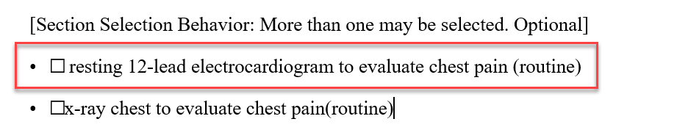

Figure 9: Order Example (Cardiology Order Set)

The order from the KNART above appears in the TSR as an Instance Request:

Figure 10: Order Set Instance Request in TSR Template

VA KNART Information Modeling Overview

The Analysis Normal Form (ANF) provides a set of guidelines to model clinical statements. A clinical statement represents an entry in the patient record that documents in a structured/computable manner clinical information about a subject of information, such as a patient or a relative of the patient, and that is asserted by a particular source, recorded, and potentially verified.

The Analysis Normal Form (ANF) constitutes a model for defining the components of data elements from KNARTs on a general level, independent of any specific terminology. The ANF defines the principles, which distinguish the “topic” of clinical statements from the “circumstances” of e.g., an action request. The topic describes the “what” whereas the circumstances describe the “how”.

Details of the ANF model for clinical statements and their components have been discussed in previous sections of this document.

Terminology Modeling Guidelines

The request and performance clinical statement types as described in the ANF Model and Guidelines section of this document have a number of shared components. Other components are specific to the statement type. The following sections will define the terminology modeling principles for each component in detail. The choice of logical expressions to use for each component is not always straightforward, and the terms in the SOLOR terminologies are not always unambiguous in their semantic meaning. In situations, where there may be more than one choice or more than one way to code a clinical statement or one of its components, it is important to ensure consistency of modeling approaches across clinical domains and clinical statements.

The following chapters will describe the terminology modeling guidelines based on the current ANF model and the current TSR template fields. The TSR template has two tabs for Instance Requests (IRs). One tab “request” contains IRs for requested actions, one tab “performance” contains IRs for performed actions. Both tabs have a number of fields in common. Some fields are different and unique to the specific type of IR.

Instance Request (Request and Performance)
Represents the clinical statement to be modeled.

statementID (Request and Performance)
Not for modeling. ID will be assigned by KNART developers.

statementType (Request and Performance)
Format: Logical Expression
Terminology: SNOMED CT
Coding: Either “385644000 |Requested (qualifier value)|” for request IRs or
“398166005 |Performed (qualifier value)|” for performance IRs

METADATA: model fit (Request and Performance)

Currently not in use.

METADATA: model fit comments (Request and Performance)
Currently not in use.

VA CDS Team IR Review Rating (Request and Performance)
Used by VA KBS Terminology approvers to rate the modeling of the IR according to standard criteria, based on the coverage of the use case (IR) within the constraints of the ANF model and the available terminology terms and model. This is NOT a rating of the “quality” of the modeling or the modeler. Only, if actual errors are detected would the modeling require correction before it can be approved.

VA CDS Team IR Review Rating Key | Result
1. Perfect fit of model and terminology with the use case. | pass
2. Meets the use case within the constraints of the model. | pass
3. Some specificity of the use case is lost, secondary to limitations of terminology modeling. | pass
4. There are significant errors that require correction. | fail
Figure 11: Rating Key

VA CDS Team Reviewer Initials (Request and Performance)
VA reviewer’s initials

subjectOfInformation (Request and Performance)
Format: Logical Expression
Terminology: SNOMED CT

Subject of information is in most cases the patient: 410604004 |Subject of record (person)|. However, if the information is about, e.g. the patient’s mother or another family member, it is not the patient.

Examples: 72705000 |Mother (person)|, 303071001 |Person in the family (person)|

topic (Request and Performance)
The topic field represents, what is being requested or has been performed. Although both request and performance IRs share this field, the handling is different to a certain extent.

Format: Logical Expression
Terminology: SOLOR

The actual coding of the topic depends on the procedure being requested or has been performed. Generally, pre-coordinated or post-coordinated expressions are used. Post-coordinated expressions can be “hybrids” and include terms from different terminology standards (See Medication example below).

The pre-coordinated or post-coordinated expressions in the topic field are ALWAYS procedures.

Medication (Request and Performance)
Currently, medications are interpreted as the administration of a medication, not the prescription. The administration can be either requested or documented as being done. Therefore, all medications are post-coordinated based on the SCT “416118004 |Administration (procedure)” concept. To capture the drug itself, RxNorm codes are used. The specific RxNorm codes depend on the specificity of the IR. Attribute/value pairs needed to fully post-coordinate the expression are SCT concepts.

Example Instance Request:

Naproxen sodium 550 mg tablet oral every 12 hours as needed for back pain 100 tablets 2 refills

Post-coordinated expression with conceptual graph syntax:

[416118004 |Administration (procedure)]
->(260686004 |Method (attribute))->[129445006 |Administration - action (qualifier value)]
->(363701004 |Direct substance (attribute))->[Rx;849431 Naproxen sodium 550 MG Oral Tablet]
->(410675002 |Route of administration (attribute))->[260548002 |Oral (qualifier value)]

Notes:
- The IR is specific enough regarding strength and dose form. Therefore, the RxNorm SCD code can be applied
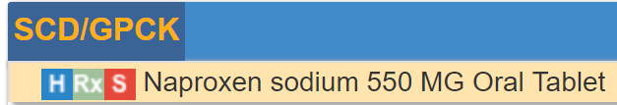
Figure 12: RxNorm SCD Code
- Other medication requests or performances are less specific. The IR might only state “Aspirin tablet”. In these cases, the RxNorm SCDG codes are used:

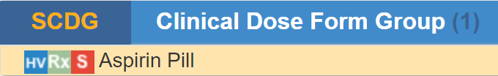
Figure 13: RxNorm SCDG Code

- If the IR states a class of drugs, e.g. “Glucocorticoids”, the coding approach is cascaded:
First choice: SNOMED CT concept from the “product” hierarchy
Second choice: NDF-RT code

- “Route of administration - oral” is included in the post-coordinated expression. Although the RxNorm code includes “oral tablet” it does not sufficiently capture, that this tablet is administered orally.

- The “Rx;” prefix for the RxNorm code in the post-coordinated expression indicated the terminology standard. Current modeling guideline: All concepts are SNOMED CT concepts, unless otherwise stated.

- The IR example states: Naproxen sodium 550 mg tablet oral every 12 hours as needed for back pain 100 tablets 2 refills. Although it is not explicitly stated, the currently agreed upon policy is, to interpret this as: 1 tablet at a time.

Coding guidelines for dosage, frequency, total number of tablets and refills etc. will be discussed in later sections. This detailed information is typically only included in medication requests, while performances typically only document that the medication has been taken as a “History of….” Statement.

Non-Medication Procedures (Request and Performance)
Other procedures in the “topic” field, e.g. diagnostic procedures, therapeutic procedures, consults or observational procedures are coded as pre-coordinated or post-coordinated expressions using SNOMED CT concepts.

For IRs (either request or performance) a “simple” procedure, e.g. “Echocardiogram”, entering the procedure code “40701008 |Echocardiography (procedure)|” in the topic field sufficiently captures the IR.

For more complex IRs, particularly where body sites or lateralities are included, some principles to ensure consistency in the modeling must be applied.

- Always post-coordinate, when “laterality” is involved
- There are many pre-coordinated SCT concepts, which include body site and laterality, e.g. “1451000087102 |Computed tomography of right lower limb (procedure)|” not all body sites in SCT are lateralized.
  - Instead of using the pre-coordinated concept above post-coordinate the body structure and the laterality:

[241570001 |Computed tomography of lower limb (procedure)]-
->(363704007 |Procedure site (attribute))->[61685007 |Lower limb structure (body structure)]-
->(272741003 |Laterality (attribute))->[ 24028007 |Right (qualifier value)];

- For IRs without involving laterality, the choice for coding the topic is cascaded:

  - 1st choice: existing pre-coordinated concept
  - 2nd choice: post-coordinated expression, using existing concepts within the
constraints of the concept model
  - 3rd choice: post-coordinated expression, using existing concepts outside the
constraints of the concept model, after discussion and approval
  - 4th choice: new SCT SOLOR extension precoordinated concept, after discussion and
approval; use generated UUID until the concept is created

Observational Procedures (Performance)
In the “performance” tab of TSRs, many of the IRs pertain to the documentation of findings or disorders. These are “observational” procedures, often documented within “history and physical” sections of documentation templates, which describe the presence or absence of a finding or disorder.

This category of IRs is always captured as a post-coordinated expression in the topic field.

Example IR: Weakness of neck

Post-coordination:
[a997cc03-3e99-40eb-833a-6374c7750a3a |Observation procedure (procedure)]
->(363702006 |Has focus (attribute))->[249931001 |Weakness of neck (finding)]

Example IR: Right arm pain

Post-coordination:
[a997cc03-3e99-40eb-833a-6374c7750a3a |Observation procedure (procedure)]-
->(363702006 |Has focus (attribute))->[22253000 |Pain (finding)]-
->(363698007 |Finding site (attribute))->[53120007 |Upper limb structure (body structure)]-
->(272741003 |Laterality (attribute))->[24028007 |Right (qualifier value)];

Unstructured (Request and Performance)
Format: Plain text

Currently used to capture textual information for which there is no model at this time.

statementAssociation.semantic (Request and Performance)
Format: Logical Expression
Terminology: TBD

Currently not in use.

statementAssociation.statementId (Request and Performance)
For use by KNART developers.

Timing (Request and Performance)
The “timing” circumstance has six components:

- timing.lowerBound
Format: Number (“float”)

- timing.upperBound
Format: Number (“float”)

- timing.includeLowerBound
Format: TRUE or FALSE (“Boolean”)

- timing.includeUpperBound
Format: TRUE or FALSE (“Boolean”)

- timing.resolution (optional)
Format: Number (“float”)

- timing.measureSemantic
Format: ISO 8601 Date/Time Format

Timing is used to capture a time or time range for
- Requests for action at a future time
- Performance of action, which has taken place in the past (including “History of X….)

The timing is always expressed as a time or time range relative to the statement time, using the ISO 8601 Date/Time Standard format.

If the actual time or time range is not specified in the IR, the following expressions are used:

- ISO 8601 prior to statement time
- ISO 8601 following statement time

If the time or time range is specified in the IR, the expression also follows the ISO 8601 Standard, using the appropriate prefixes for periods of time:

- P for period
- M for months
- W for weeks
- Y for years

Using additional fields in the timing circumstance, depends upon the degree of specificity within the IR.

Example (unspecific): History of breast cancer

timing.lowerBound | 1
timing.upperBound | inf
timing.includeLowerBound | TRUE
timing.includeUpperBound | FALSE
timing.resolution
timing.measureSemantic | ISO 8601 prior to statement time

Table 2: Timing - unspecific

The IR implies:
- Breast cancer was present in the patient’s history = timing.lowerBound = 1
- No time range specified = timing.upperBound = inf (infinite)
- There was at least 1 instance = timing.includeLowerBound = TRUE
- “upper bound” is infinite = timing.includeUpperBound = FALSE (“inf” is never included!)
- IR does not specify units of time, e.g. years, months = timing.resolution = blank

Note: The expression of “present” could also be correctly indicated using

timing.lowerBound = 0
timing.includeLowerBound = FALSE

Not including “0” also expresses that there has to be at least “1”. However, it is the current agreed policy to use the “1/TRUE” option.

Example (specific range): Anticonvulsant therapy greater than 2 years

timing.lowerBound | 24M
timing.upperBound | inf
timing.includeLowerBound | FALSE
timing.includeUpperBound | FALSE
timing.resolution | 1M
timing.measureSemantic | ISO 8601 prior to statement time

Table 3: Timing - specific range

The IR expresses:
- Anticonvulsant therapy for more than 2 years (24 months) was present in the patient’s history = timing.lowerBound = 24M
- No upper time limit specified = timing.upperBound = inf (infinite)
- There was anticonvulsant therapy for more than 24 months = timing.includeUpperBound = FALSE
- Timing.measureSemantic = ISO 8601 prior to statement time
- timing.resolution field:
  - This field is optional, but if a time or time range is specified, the resolution has to be specified.
  - The use depends on the desired granularity of the time increments
  - Some of the reasoning about how to use these fields depends on the clinical relevance.

Example (specific date): Completed Appointed on March 12 2018 with Cardiology

timing.lowerBound | 2018-03-19T12:01
timing.upperBound | 2018-03-19T23:59
timing.includeLowerBound | TRUE
timing.includeUpperBound | TRUE
timing.resolution
timing.measureSemantic | ISO 8601

Table 4: Timing - specific date

Note: ISO 8601 uses the 24 hour standard for time of day.

Purpose (Request and Performance)
Format: Logical Expression
Terminology: SNOMED CT

The “purpose” field is used to capture WHY a procedure was requested or performed in a post-coordinated expression, based on two possible procedures:

Evaluation procedure: 386053000 |Evaluation procedure (procedure)|
Therapeutic procedure: 277132007 |Therapeutic procedure (procedure)|

The procedure is refined by post-coordinating with a “363702006 |Has focus (attribute) |” attribute and identifying a finding/disorder or procedure concept as the value for the attribute.

Example IR: Resting 12-lead electrocardiogram to evaluate for arrhythmia

[386053000 |Evaluation procedure (procedure)]
->(363702006 |Has focus (attribute))->[ 698247007 |Cardiac arrhythmia (disorder)]

Example IR: Naproxen sodium 550 mg tablet oral every 12 hours as needed for back pain 100 tablets 2 refills

[277132007 |Therapeutic procedure (procedure)]
->(363702006 |Has focus (attribute))->[161891005 |Backache (finding)]

IRs can have more than one purpose.

requestedResult (Request and Performance)

The “requestedResult” circumstance has eight components:

- requestedResult.lowerBound
Format: Number (“float”)

- requestedResult.upperBound
Format: Number (“float”)

- requestedResult.includeLowerBound
Format: TRUE or FALSE (“Boolean”)

- requestedResult.includeUpperBound
Format: TRUE or FALSE (“Boolean”)

- requestedResult.resolution (optional)
Format: Number (“float”)

- requestedResult.measureSemantic
Format: Logical Expression

- requestedResult.healthRisk
Format: Logical Expression

- requestedResult.status
Format: Logical Expression

The “requestedResult” fields 1 – 6 above are used to capture IRs, which
- enumerate what is being requested, e.g. Administration of a medication 1 tablet at a time
- specify the intended outcome of an action, e.g. Administration of Metoprolol to achieve systolic BP < 130 mmHg

Example IR: Metoprolol tartrate 50 mg tablet oral daily 2 times

requestedResult.lowerBound | 1
requestedResult.upperBound | 1
requestedResult.includeLowerBound | TRUE
requestedResult.includeUpperBound | TRUE
requestedResult.resolution
requestedResult.measureSemantic | 421026006 |Oral tablet (qualifier value)|

Table 5: requestedResult - Example 1

Note: This should not be confused with “frequency”. Although not stated explicitly, it is understood that the IR states: ONE tablet, twice a day.

Example IR: Acetaminophen 325 mg tablet oral two tablets every 6 hours

requestedResult.lowerBound | 2
requestedResult.upperBound | 2
requestedResult.includeLowerBound | TRUE
requestedResult.includeUpperBound | TRUE
requestedResult.resolution
requestedResult.measureSemantic | 421026006 |Oral tablet (qualifier value)|

Table 6: requestedResult - Example 2

conditionalTrigger (Request)

Format: Logical Expression
Terminology: TBD

Currently not in use.

conditionalTrigger.statementId (Request)

UUID as identifier for the conditionalTrigger statement.

Priority (Request)

Format: Logical Expression
Terminology: SNOMED CT

The priority field captures the standard priorities associated with a request for action, e.g. stat, routine

repetition.period (Request)

The “repetition.period” has twelve components. Six components for the repetition period start and six components for the repetition period duration. The fields are used to capture WHEN a repeated action should start and HOW LONG the requested action should be repeated.

- repetition.periodStart.lowerBound
Format: Number (“float”)

- repetition.periodStart.upperBound
Format: Number (“float”)

- repetition.periodStart.includeLowerBound
Format: TRUE or FALSE (“Boolean”)

- repetition.periodStart.includeUpperBound
Format: TRUE or FALSE (“Boolean”)

- repetition.periodStart.resolution (optional)
Format: Number (“float”)

- repetition.periodStart.measureSemantic
Format: Logical Expression

repetition.period components
Example IR: Naproxen sodium 550 mg tablet oral every 12 hours as needed for back pain

repetition.periodStart.lowerBound | [NOW,NOW] relative to statement time
repetition.periodStart.upperBound
repetition.periodStart.includeLowerBound
repetition.periodStart.includeUpperBound
repetition.periodStart.resolution
repetition.periodStart.measureSemantic
repetition.periodDuration.lowerBound | 1
repetition.periodDuration.upperBound | inf
repetition.periodDuration.includeLowerBound | TRUE
repetition.periodDuration.includeUpperBound | FALSE
repetition.periodDuration.resolution | 1
repetition.periodDuration.measureSemantic | 258703001 |day (qualifier value)|

Table 7: repetition.period Example
If the IR does not explicitly state a period start time, the default entry in this field is “[NOW,NOW] relative to statement time”.
Note: “[NOW,NOW]” is not to be confused with priority “stat”. The “NOW” is simply used, where there is not a specified time, e.g. 1 week from now.
If a repetition period start/stop time is specified, the “upper/lower bound” components and the measureSemantic are used as in all other timing related circumstances.

repetition.periodDuration components
Every repetition has a duration, even if it is not explicitly stated in the IR. In the example above, the IR states a frequency (every 12 hours), but not a duration. In these cases it is understood that the duration is “infinite”. The same understanding is true for IR statements described as “daily”. The “upper/lower bound” components and the “measure.semantic” are used in the same way as in all other timing related circumstances.

repetition.eventFrequency (Request)
This circumstance is used to capture the requested frequency of any repeated action, e.g. 3 times/day, once/week.

The “repetition.eventFrequency” circumstance has six components.

- repetition.eventFrequency.lowerBound
Format: Number (“float”)

- repetition.eventFrequency.upperBound
Format: Number (“float”)

- repetition.eventFrequency.includeLowerBound
Format: TRUE or FALSE (“Boolean”)

- repetition.eventFrequency.includeUpperBound
Format: TRUE or FALSE (“Boolean”)

- repetition.eventFrequency.resolution (optional)
Format: Number (“float”)

- repetition.eventFrequency.measureSemantic
Format: Logical Expression

Example IR: Naproxen 550mg tablet oral every 12 hours

repetition.eventFrequency.lowerBound | 12
repetition.eventFrequency.upperBound | 12
repetition.eventFrequency.includeLowerBound | TRUE
repetition.eventFrequency.includeUpperBound | TRUE
repetition.eventFrequency.resolution
repetition.eventFrequency.measureSemantic | 258702006 |hour (qualifier value)|

Table 8: repetition.eventFrequency - Example 1

Example IR: Ibuprofen 400 mg tablet oral every 6 hours; may increase dose frequency to one tablet every 4 hours

repetition.eventFrequency.lowerBound | 4
repetition.eventFrequency.upperBound | 6
repetition.eventFrequency.includeLowerBound | TRUE
repetition.eventFrequency.includeUpperBound | TRUE
repetition.eventFrequency.resolution
repetition.eventFrequency.measureSemantic | 258702006 |hour (qualifier value)|

Table 9: repetition.eventFrequency - Example 2
The “upper/lower bound” components and the measureSemantic are used as in all other timing related circumstances.

repetition.eventSeparation (Request)

Currently not in use.

repetition.eventDuration (Request)

This circumstance will be used to capture, HOW LONG each requested event should last, e.g. “Physical therapy 3 times per week for 1 hour.

Currently not in use.

Appendix A: Modeling Principles Definitions

- Separation of Concerns: As defined by Wikipedia: Separation of Concerns (SoC) is a design principle for separating a computer program into distinct sections, such that each section addresses a separate concern. A concern is a set of information that affects the code of a computer program. A concern can be as general as the details of the hardware the code is being optimized for, or as specific as the name of a class to instantiate. A program that embodies SoC well is called a modular program. Modularity, and hence separation of concerns, is achieved by encapsulating information inside a section of code that has a well-defined interface. Encapsulation is a means of information hiding. Layered designs in information systems are another embodiment of separation of concerns (e.g., presentation layer, business logic layer, data access layer, persistence layer). The value of separation of concerns is simplifying development and maintenance of computer programs. When concerns are well-separated, individual sections can be reused, as well as developed and updated independently. Of special value is the ability to later improve or modify one section of code without having to know the details of the other sections, and without having to make corresponding changes to those sections.
The use of immutable objects (see principle B Immutability below) is a technique that fulfills the Separation of Concerns principle.
Attributes that describe specific semantic concepts should be grouped together into a single class and not be spread across a number of classes. Doing the latter leads to tight coupling between classes. Doing the former leads to better decomposition of a potentially complex domain.
- Example: Attributes for a Role (e.g., Practitioner) should not be mixed with attributes for an Entity (e.g., Person). This allows a person to assume a number of roles over their lifetime or to function in more than one role.

- Immutability: An Immutable Object as defined by Wikipedia: Used in object-oriented and functional programming, an immutable object is something that cannot be changed after it is created, in contrast to mutable objects that can be changed after they are created. There are multiple reasons for using immutable objects, including improved readability and runtime efficiency and higher security.
Although building immutable objects requires a bit more up-front complexity, the downstream simplification forced by this abstraction easily offsets the effort. One of the benefits of switching to a functional mindset is the realization that tests exist to check that changes occur successfully in code. In other words, testing’s real purpose is to validate mutation – and the more mutation you have, the more testing is required to make sure you get it right. If you isolate the places where changes occur by severely restricting mutation, you create a much smaller space for errors to occur and have few plates to test.
Finally, one of the best features of immutable classes is how well they fit into the composition abstraction.
- Composition Over Inheritance: Composition over inheritance (or composite reuse principle) in object-oriented programming is the principle that classes should achieve polymorphic behavior and code reuse by their composition (by containing those instances of other classes that implement the desired functionality) rather than inheritance from a base or parent class.
To favor composition over inheritance is a design principle that gives the design higher flexibility. It is more natural to build business-domain classes out of various components than trying to find commonality between them and creating a family tree.
Initial design is simplified by identifying system object behaviors in separate interfaces instead of creating a hierarchical relationship to distribute behaviors among business-domain classes via inheritance. This approach more easily accommodates future requirements changes that would otherwise require a complete restructuring of business-domain classes in the inheritance model.
Item for Consideration: Should we say that we only allow inheritance for a single concern, i.e., we can subtype measurement but not subtype a combination of statement type and measurement type?
- ANF Clinical Statements Represent the Minimum Disjoint Set: Analysis Normal Form (ANF) clinical statements represent the minimum disjoint set of statement topic, result, and circumstance and may not be further specified.
- ANF Classes Cleanly Separate Concerns: Analysis Normal Form (ANF) classes must cleanly separate the concerns of concept definition and the concerns of domain models.
- NOTE: Need to define the domain models thoroughly here. The strawman description is that domain models use concept definitions as a building block to define non-defining relationships or associations between concepts. The domain model represents cardinality, optionality, and other constraints.
  - Example: Laterality should be a concern of either the concept definition or the domain model, but not both. We can relax this principle for the Clinical Input Form (CIF) but for ANF we need a clean and invariant separation of concerns.
- NOTE: Need to determine better names for “concept definition” and “domain models.”
- Clinical Statement Model Stability: Stability is different from immutability. Stable means that the model can still meet unanticipated requirements without having to change. It is not acceptable to change the model every time a new way to administer a drug or to treat a condition is identified. By representing these types of potentially dynamic concerns in the terminology expressions, as opposed to static fields in a class structure, we do not have to change the model every time something new is discovered. As Terry Winograd said, anticipating breakdowns, and providing a space for action when they occur, is a design imperative.
In some regards, in this context “stable” means “not brittle.” A model easily broken by changes that someone could anticipate is one possible definition of brittle. A stable model is critical in the phase of a known changing landscape. We do that by isolating areas of anticipated change into a dynamic data structure. That dynamic data structure may also be immutable in an object that represents a clinical statement.
- Overall Model Simplicity: In cases where different principles collide, we shall favor the enhancement of simplicity of the entire system over simplicity in one area of the system.
- Cohesion: Related classes should reside in the same module or construction. The placement of a class in a module should reduce the dependencies between modules.
- Reusability: Architectural patterns should encourage class reusability where possible. Reusability may further refine encapsulation when composition is considered.
- Assumption-free: Implied semantics must be surfaced explicitly in the model.
- Example: Implicit in the statement, “I order a book from Amazon” are: paying for the book, delivery of the book to some location, and the transfer of ownership of the book from the vendor to the client.
- Design by Composition and/or Class Specialization: The capture of additional model expressivity must be captured by composition and/or by class specialization. The modeling approach should avoid the use of design by constraint (except for terminology binding and attribute type constraints) as it violates proper decoupling and encapsulation. An example of design by constraint is to create a single procedure class containing all attributes for all known procedures and constraining out irrelevant attributes in a more specialized model. This approach is very difficult to implement and violates numerous object-oriented best practices.
- No False Dichotomies: Dichotomies that are not completely disjoint (mutually exclusive) lead to arbitrary classification rules and result in ambiguity based on different assumptions about the domain. These must be avoided.
- Model Should Avoid Semantic Overloading (semantic precision): Semantic overloading occurs when a model attribute’s meaning changes entirely, depending on context. While the refinement of the semantics of an attribute in a subclass is acceptable, a change of meaning is problematic. For instance, in FHIR, the Composition class defines an attribute called Subject. In some subclasses, the attribute may be the entity that this composition refers to (e.g., the patient in a medical record). In other cases, it is the topic being discussed by the composition (e.g., a medication orderable catalog).
- Convention Over Configuration: Convention over configuration (also known as coding by convention) is a software design paradigm used by software frameworks that attempt to decrease the number of decisions that a developer using the framework is required to make without necessarily losing flexibility.
- Model Consistency: Patterns should allow the consistent representation of information that is commonly shared across models. For instance, attribution and participation information should be captured consistently. Failure to do so forces implementers to develop heuristics to capture and normalize attribution information that is represented or extended differently in different classes (e.g., FHIR).
- Model Symmetry: There should be symmetry in the models wherever we can have it.
- Iterative development and validation of model using use cases: TBD

Appendix B: Use Case for Modeling of Clinical Statements Using Analysis Normal Form

Depression: Follow-up outpatient visit (slightly adapted)

ACTORS
- Patient
- Medical Office Assistant
- Provider
PRECONDITIONS
This is a 32-year old male with a 6-month history of major depression on Zoloft and receiving group psychotherapy. Risk assessment scores from the last visit 1 month ago: PHQ-9 (15), PCL (16), AUDIT-C (0), ASSIST (10) for tobacco only. No suicidal ideation or risk of violence towards others.

- PMH: Patient had right above the knee amputation (AKA) 6 months ago and has prosthesis. Denies substance use of medications. Smokes 2 ppd. Patient does not have a traumatic brain injury (TBI).
- Psychosocial: Patient is S/P 2 deployments to Afghanistan, is estranged from family, has no close friends, lives alone, and is unemployed. His best friend died during their last deployment together, when the patient was injured. He attends AA meetings daily, is undergoing vocational rehabilitation and has been seen by a community social service agency.
WORKFLOW
- After patient arrives to the clinic and is checked in, he uses a VA tablet to complete risk assessments and the tablet is synced to the EHR. Patient’s scores are:
  - PHQ-9: 17
  - PCL: 15
  - AUDIT-C: 0
  - ASSIST: 10 for tobacco only
- Patient is taken to a room and the MOA asks patient for their chief complaint (CC) and any updates to their psychosocial and medical history. MOA reviews and validates the reason for visit is a routine outpatient visit for depression and PTSD management. Patient has no updates to psychosocial history.
- MOA validates patient’s medication history has not changed. Patient is taking 1 Zoloft 150 mg p.o. daily.
- MOA takes patient’s vital signs:
  - Height = 72”
  - Weight = 176 lbs
  - BMI = 23.9
  - Heart rate = 80 bpm
  - Respirations = 18 / min
  - Blood Pressure = 124/74 mmHg
  - Temperature = 98.2F
- Provider reviews the patient record prior to entering the room, including seeing that the PHQ score has increased from 15 from a month ago, to 17 today.
- Provider asks the patient how he is feeling, along with his concerns. Patient: “I’m not very good. I’m so tired all the time. I’m not sleeping well and I have trouble concentrating. I go to my AA meetings, but that is about it.” After discussion with the patient, the provider also learns the patient is concerned about long term living accommodations and won’t be able to afford rent beyond the next 4 months.
- Provider completes a psychiatric evaluation. Patient’s mental status is assessed as:
  - Appearance: Poorly groomed, patient slouching
  - Behavior: Subdued
  - State of Consciousness: Alert and oriented x 3
  - Attention: Slow to respond, shrugs shoulders in response to some questions
  - Speech: Soft, coherent
- Provider performs medication reconciliation and validates that patient is taking Zoloft 150 mg p.o. daily.
- Provider completes a head to toe assessment:
  - Head/Neuro: WNL
  - Heart: S1S2, BP normal
  - Lungs: Clear
  - Abdomen: Soft, benign. No GI/GU issues.
  - Extremities: No swelling, pedal pulses strong.
- After discussion about the patient’s worsening depression and the need to adjust treatment to better manage the patient’s condition, Provider and patient agree upon the following changes to the care regimen, which are documented in the Care Plan:
  - Continue Zoloft 150 mg p.o. daily / Immediately
  - Start Venlafaxine 37.5 mg daily x 4 days, then increase to 37.5 mg twice daily / Immediately
  - Referral for weekly individual psychotherapy (provider responsibility; 20 sessions; diagnosis=depression, PTSD; reason=worsening depression) / Now
  - Make appointment for weekly individual psychotherapy (patient responsibility) / Immediately
  - Continue weekly group psychotherapy / Ongoing
  - Referral to Supported Housing Services provided. Patient to follow-up / Immediately
  - Continue Vocational Rehabilitation Training / Ongoing
  - Follow-up in 2 weeks to evaluate for medication side effects
- Provider discusses with patient the patient’s goals to manage his health. The patient states he would like to complete the Vocational Rehabilitation Training. He feels that he can complete it within 6 months, if his housing situation is resolved and he won’t be homeless.

Breakdown of encounter into clinical statements

Requests
  - Medication: 1 Venlafaxine 37.5 mg tablet daily x 4 days, then increase to 37.5 mg twice daily
    - Topic: Administration of Venlafaxine 37.5 mg tablet
    - Circumstance:
      - Dosage: 1 tablet
      - Frequency: Daily
      - Duration: 4 days
      - Instructions: After 4 days, increase to 37.5 mg twice daily
  - Referral: Weekly individual psychotherapy, 20 sessions, diagnosis = depression, PTSD, reason=worsening depression
    - Topic: Referral for Individual Psychotherapy
    - Circumstance:
      - Repetition Event Frequency: 20
      - Purpose: Therapeutic; Worsening depression, PTSD
  - Referral: Supported Housing Services
    - Topic: Referral to Supported Housing Services

Observational Actions (These need to be split out by topic, result, and details)
  - Height
    - Topic: Observation of body height (coded)
    - Result: 72
    - UOM = inches height (coded)
  - Weight
    - Topic: Observation of body weight (coded)
    - Result: 176
    - UOM = pounds (coded)
  - BMI
    - Topic: Observation of BMI (coded)
    - Result: 23.9
  - Heart rate
    - Topic: Observation of heart rate (coded)
    - Result: 80
    - UOM = bpm (coded)
  - Respirations
    - Topic: Observation of respiratory rate (coded)
    - Result: 18
    - UOM = bpm (coded)
  - Systolic BP:
    - Topic: Observation of systolic BP (coded)
    - Result: 124
    - UOM =mmHg (coded)
    - Associated statements: seated, patient urinated at least 30 minutes before BP taken (coded)
  - Diastolic BP:
    - Topic: Observation of diastolic BP (coded)
    - Result: 74
    - UOM =mmHg (coded)
    - Associated statements: seated, patient urinated at least 30 minutes before BP taken (coded)
  - Temperature:
    - Topic: Observation of body temperature (coded)
    - Result: 98.2
    - UOM = degrees F (coded)

  - Appearance:
    - Topic: Psychiatric evaluation of patient appearance (coded)
    - Result: poorly groomed, patient slouching (coded)
  - Behavior:
    - Topic: Psychiatric evaluation of patient behavior (coded)
    - Result: subdued (coded)
  - State of consciousness:
    - Topic: Psychiatric evaluation of patient state of consciousness (coded)
    - Result: Alert and oriented x 3 (coded)
  - Attention:
    - Topic: Psychiatric evaluation of patient attention (coded)
    - Result: Slow to respond, shrugs shoulders in response to some questions (coded)
  - Speech:
    - Topic: Psychiatric evaluation of patient speech (coded)
    - Result: Soft, coherent (coded)
  - Head/Neuro exam:
    - Topic: Head and neurologic examination (coded)
    - Result: Within normal limits (coded)
  - Heart exam:
    - Topic: Examination of heart (coded)
    - Result: S1S2, BP normal (coded)
  - Lungs exam:
    - Topic: Examination lungs (coded)
    - Result: clear (coded)
  - Abdomen exam:
    - Topic: Examination of abdomen (coded)
    - Result: Soft, benign. No GI/GU issues (coded)
  - Extremities exam:
    - Topic: Examination of extremities (coded)
    - Result: No swelling, pedal pulses strong (coded)
  - Patient attending weekly group psychotherapy
    - Topic: Group psychotherapy (coded)
    - Frequency: weekly (coded)
    - Result Status: Done (coded)
  - Patient enrolled in Vocational Rehabilitation Training
    - Topic: Vocational Rehabilitation Training (coded)
    - Result Status: Done (coded)
  - Goal = Complete Vocational Rehabilitation Training within 6 months, provided his housing situation is resolved and he won’t be left homeless
    - Topic: Vocational Rehabilitation Training (coded)
    - Result: 6 months (coded)
    - Result Status: Completed (coded)

https://en.wikipedia.org/wiki/Conceptual_graph#Graph-based_knowledge_representation_and_reasoning_model
https://en.wikipedia.org/wiki/ISO_8601
https://en.wikipedia.org/wiki/Separation_of_concerns
https://en.wikipedia.org/wiki/immutable_object

