HSPC Interoperability and Services Enterprise Workgroup Roadmap
Summary Tables: 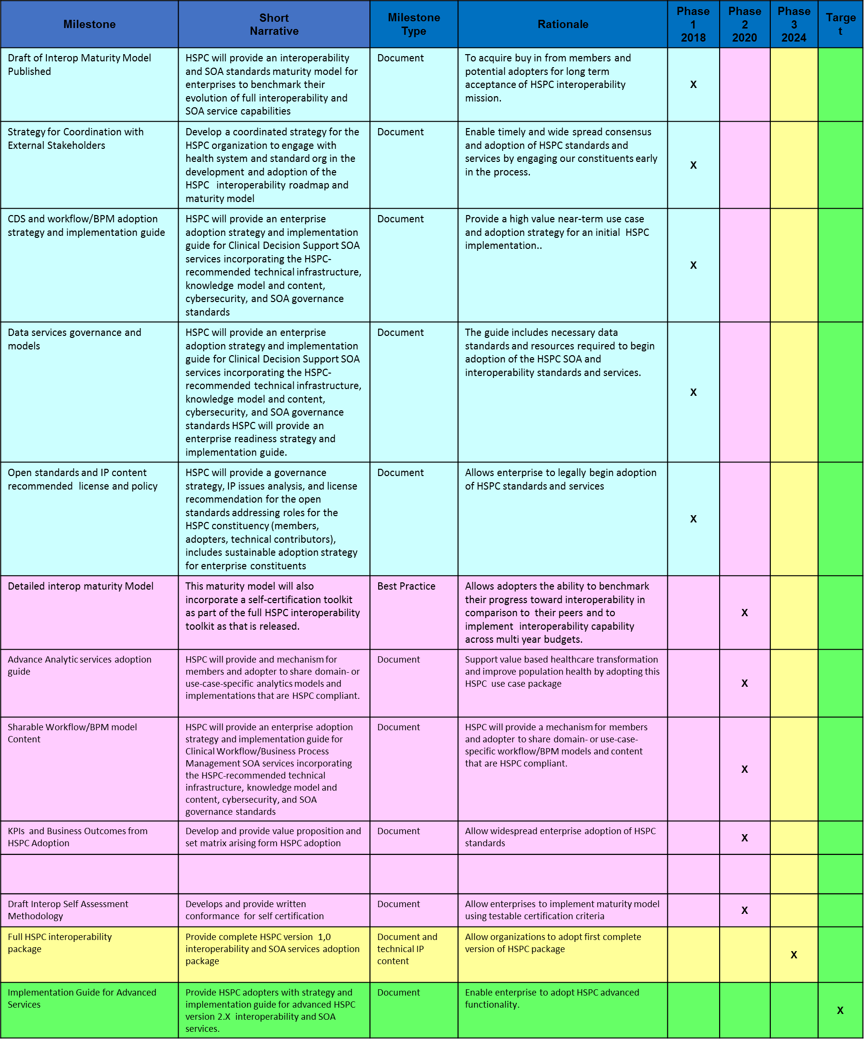

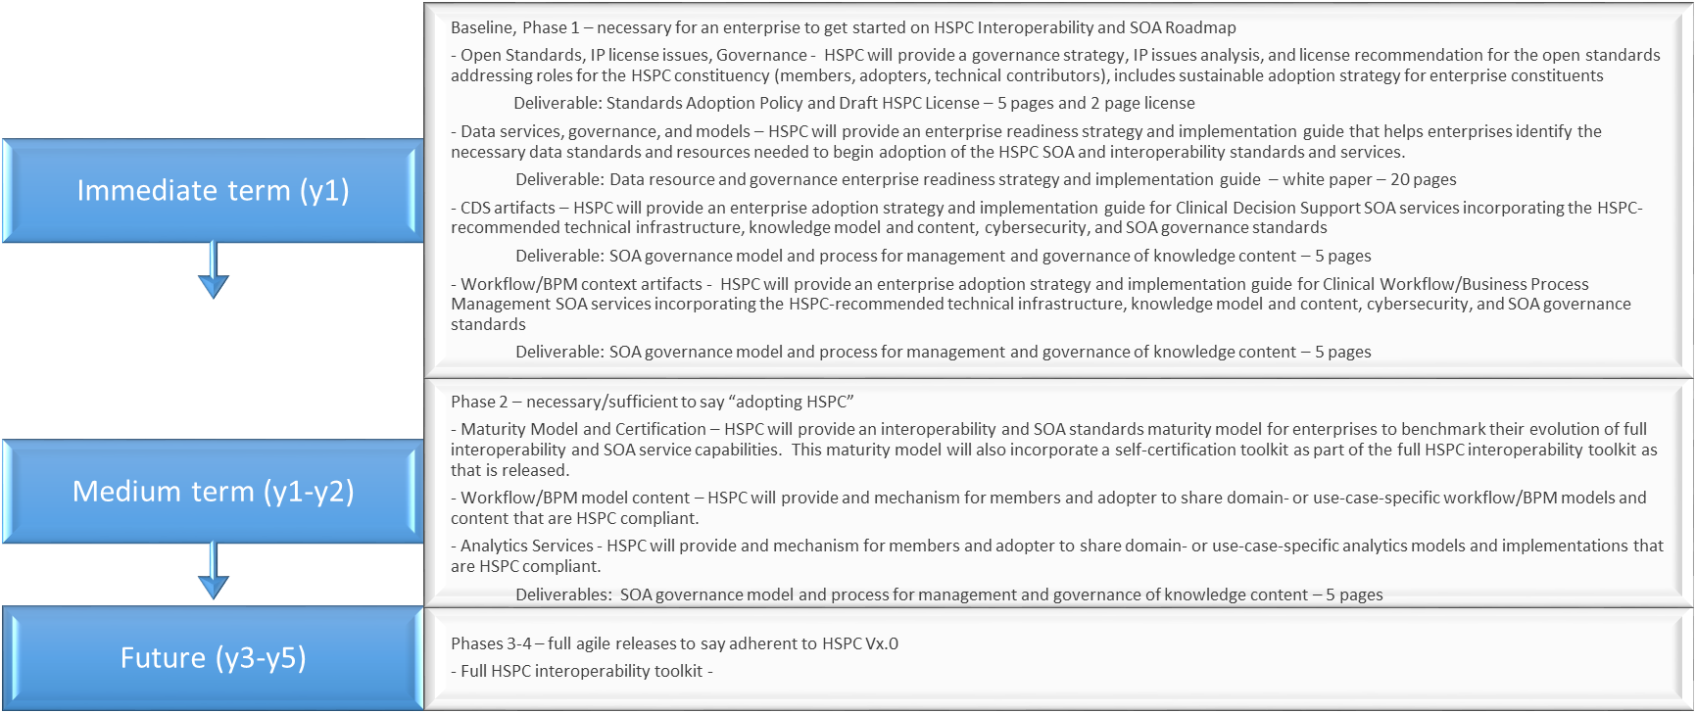
Metadata
Phase 1 - These are activities that are necessary for an enterprise to get started on HSPC Interoperability and SOA Roadmap
Metadata Item | Guidance | Notes
Milestone Name | Draft of Interop Maturity Model Published
Short Narrative Description | HSPC will provide an interoperability and SOA standards maturity model for enterprises to benchmark their evolution of full interoperability and SOA service capabilities
Milestone Type | Document
Rationale | To acquire buy in from members and potential adopters for long term acceptance of HSPC interoperability mission.
Phase I? | Yes
Phase 2? | No
Phase 3? | No
Phase 4? | No
Dependencies

Metadata Item | Guidance | Notes
Milestone Name | Strategy for Coordination with External Stakeholders
Short Narrative Description | Develop a coordinated strategy for the HSPC organization to engage with health system and standard org in the development and adoption of the HSPC interoperability roadmap and maturity model
Milestone Type | Document
Rationale | Enable timely and wide spread consensus and adoption of HSPC standards and services by engaging our constituents early in the process
Phase I? | Yes
Phase 2? | No
Phase 3? | No
Phase 4? | No
Dependencies

Metadata Item | Guidance | Notes
Milestone Name | CDS and workflow/BPM adoption strategy and implementation guide
Short Narrative Description | HSPC will provide an enterprise adoption strategy and implementation guide for Clinical Decision Support SOA services incorporating the HSPC-recommended technical infrastructure, knowledge model and content, cybersecurity, and SOA governance standards
Milestone Type | Document
Rationale | Provide a high value near-term use case and adoption strategy for an initial HSPC implementation.
Phase I? | Yes
Phase 2? | No
Phase 3? | No
Phase 4? | No
Dependencies

Metadata Item | Guidance | Notes
Milestone Name | Data services governance and models
Short Narrative Description | HSPC will provide an enterprise adoption strategy and implementation guide for Clinical Decision Support SOA services incorporating the HSPC-recommended technical infrastructure, knowledge model and content, cybersecurity, and SOA governance standards HSPC will provide an enterprise readiness strategy and implementation guide.
Milestone Type | Document
Rationale | The guide includes necessary data standards and resources required to begin adoption of the HSPC SOA and interoperability standards and services.
Phase I? | Yes
Phase 2? | No
Phase 3? | No
Phase 4? | No
Dependencies

Metadata Item | Guidance | Notes
Milestone Name | Open standards and IP content recommended license and policy
Short Narrative Description | HSPC will provide a governance strategy, IP issues analysis, and license recommendation for the open standards addressing roles for the HSPC constituency (members, adopters, technical contributors), includes sustainable adoption strategy for enterprise constituents
Milestone Type | Document
Rationale | Allows enterprise to legally begin adoption of HSPC standards and services
Phase I? | Yes
Phase 2? | No
Phase 3? | No
Phase 4? | No
Dependencies

Phase 2 - These are activities that are necessary/sufficient to say “adopting HSPC”
Metadata Item | Guidance | Notes
Milestone Name | Detailed interop maturity Model
Short Narrative Description | This maturity model will also incorporate a self-certification toolkit as part of the full HSPC interoperability toolkit as that is released.
Milestone Type | Document
Rationale | Allows adopters the ability to benchmark their progress toward interoperability in comparison to their peers and to implement interoperability capability across multiyear budgets.
Phase I? | No
Phase 2? | Yes
Phase 3? | No
Phase 4? | No
Dependencies

Metadata Item | Guidance | Notes
Milestone Name | Advance Analytic services adoption guide
Short Narrative Description | HSPC will provide and mechanism for members and adopter to share domain- or use-case-specific analytics models and implementations that are HSPC compliant.
Milestone Type | Document
Rationale | Support value based healthcare transformation and improve population health by adopting this HSPC use case package
Phase I? | No
Phase 2? | Yes
Phase 3? | No
Phase 4? | No
Dependencies

Metadata Item | Guidance | Notes
Milestone Name | Sharable Workflow/BPM model Content
Short Narrative Description | HSPC will provide an enterprise adoption strategy and implementation guide for Clinical Workflow/Business Process Management SOA services incorporating the HSPC-recommended technical infrastructure, knowledge model and content, cybersecurity, and SOA governance standards
Milestone Type | Document
Rationale | HSPC will provide a mechanism for members and adopter to share domain- or use-case-specific workflow/BPM models and content that are HSPC compliant.
Phase I? | No
Phase 2? | Yes
Phase 3? | No
Phase 4? | No
Dependencies

Metadata Item | Guidance | Notes
Milestone Name | KPIs and Business Outcomes from HSPC Adoption
Short Narrative Description | Develop and provide value proposition and set matrix arising from HSPC adoption
Milestone Type | Document
Rationale | Allow widespread enterprise adoption of HSPC standards
Phase I? | No
Phase 2? | Yes
Phase 3? | No
Phase 4? | No
Dependencies

Metadata Item | Guidance | Notes
Milestone Name | Draft Interop Self-Assessment Methodology
Short Narrative Description | Develops and provide written conformance for self-certification
Milestone Type | Document
Rationale | Allow enterprises to implement maturity model using testable certification criteria
Phase I? | No
Phase 2? | Yes
Phase 3? | No
Phase 4? | No
Dependencies

- Phase 3 - These are activities that are necessary for full agile releases and for an enterprise to say they are adherent to initial full HSPC functionality (HSPC V1.x)
Metadata Item | Guidance | Notes
Milestone Name | Full HSPC interoperability  package
Short Narrative Description | Provide complete HSPC version 1,0 interoperability and SOA services adoption package
Milestone Type | Document and technical IP content
Rationale | Allow organizations to adopt first complete version of HSPC package
Phase I? | No
Phase 2? | No
Phase 3? | Yes
Phase 4? | No
Dependencies

Phase 4 - These are activities that are necessary for full agile releases and for an enterprise to say they are adherent to advanced HSPC functionality (HSPC V2.x)
Metadata Item | Guidance | Notes
Milestone Name | Implementation Guide for Advanced Services
Short Narrative Description | Provide HSPC adopters with strategy and implementation guide for advanced HSPC version 2.X interoperability and SOA services.
Milestone Type | Document
Rationale | Enable enterprise to adopt HSPC advanced functionality.
Phase I? | No
Phase 2? | No
Phase 3? | No
Phase 4? | Yes
Dependencies

